Theoretical Knowledge

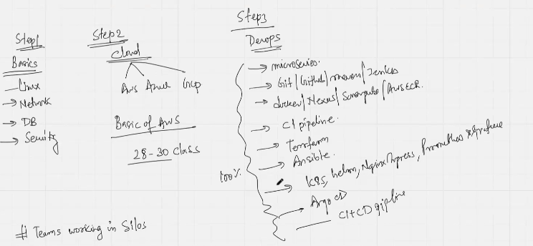

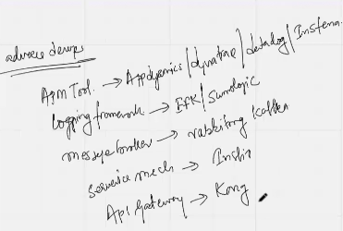

>> 4 Types of DevOps Practices

* OpenSource – Kubernetes, Terraform, Jenkins, Docker
* AWS DevOps – CodeBuild, Code Pipeline, CodeCommit
* Azure DevOps
* GCP DevOps

>> 6 Certifications

* AWS Associate
* Kubernetes associate
* Terraform associate
* Kong associate
* Prometheus
* Kibana

>> SDLC

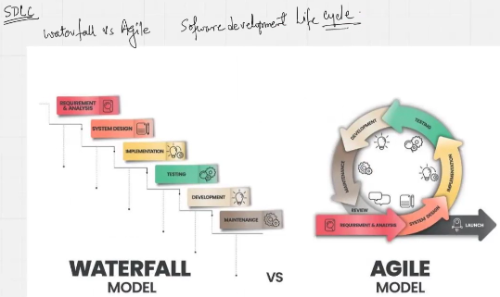

>> Bridge

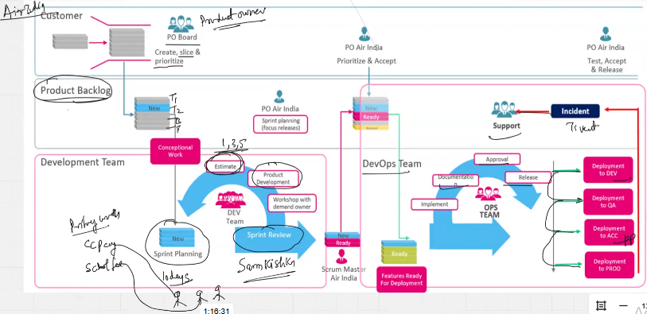

>> Python for AI/ML with MLOps

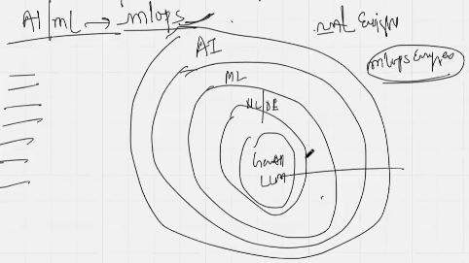

>> Selection of Automated deployment is the cusp of DevOps

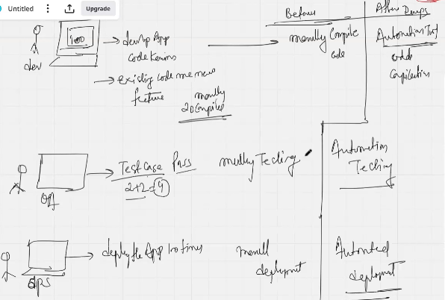

Key benefit of realizing above difference is to note that we are no more dependent on a single person for deployment.

>> Architecture

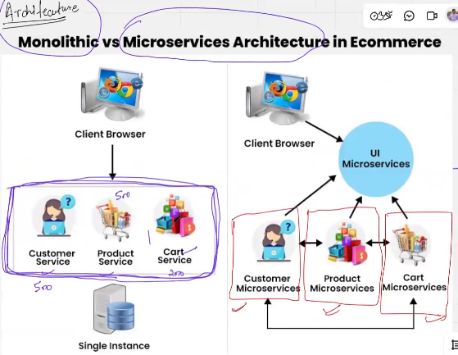

>>MAKEMYTRIP APPLICATION – Differences between monolithic and micro services architecture

